<div align="center"><div align="center"><div align="center"><div align="center">
<big>ISP 2030: Interdisciplinary Studies Seminar  &</big>  ISP 3080: Capstone Conference<big>  Interdisciplinary Studies Program</big>  Wayne State University  Fall 2007  →Please visit this class online: www.is.wayne.edu/mnissani/20302005/ | 

“If you don’t have time to read, you don’t have the time (or the tools) to write. Simple as that.”—Stephen King

The Stephen King quote above, called an “epigraph,” defines the teaching philosophy of the ISP 2030/3080 team. Reading is at the base of an essential triangle of skills for success in academic study, professional work, and your personal life. Reading, writing, and critical evaluation are not separate acts. They interrelate in a dynamic triangulation of capacities. In keeping with this philosophy, the team has prepared a packet of appealing readings that are both cross-cultural and cross-disciplinary. Our teaching methodology, or “pedagogy,” likewise triangulates activities that will help students hone skills of reading comprehension, structured writing, and critical evaluation. The readings are grouped for the most part into the following themes: the nature of good education, life changes and choices, the African-American experience, women, science, and critical thinking. Development of related skills of reading, writing, and critical thinking will give you confidence in your own intellectual powers and a respect for the integrity of higher education, the life of the mind, curiosity, and a love of reading, in addition to cultivating pertinent skills of computer use and interdisciplinary thinking. In no case will plagiarism be tolerated, because it is a betrayal of those values.

ISP 2030/3080 SECTIONS
CRN 2030/3080 | Rm. / Bldg. | Days | Time | Instructor | Actual Enrollment
14056/13270 | WCC | Mon | 6-9pm | ?
/14095 | Macomb Cen. | Mon | 6-9pm | Koscielski
14074/13290 | 0262 Manoog | Tue | 6-9pm | ?
15340/15341 | Oakland Cen. | Tue | 6-9pm | ?
14073/13277 | 0124 Cohn | Wed | 6-9pm | Ntiri
14072/13935 | 0116 State | Sat | 9:35 am - 12:35 pm | Ntiri
14071/13275 | 0118/State | Sat | 9:35 am - 12:35 pm | Nissani

State Hall is located at 5143 Cass. To view an online map of State Hall, please go to: http://campusmap.wayne.edu/?location=STAT
General Lectures Bldg. is located at 5045 Anthony Wayne. To view an online map please go to: http://campusmap.wayne.edu/?location=LECT
To view an online map of all campus locations, please go to: www.campusmap.wayne.edu/index.php

This course is comprised of 12 3-hour workshops and 2 8-hour Saturday sessions. Thus, twice throughout the term, the regular 3-hour class is cancelled; instead, all ISP 2030/3080 students attend two 8-hour Saturday sessions at a different location than their regular class session:

→Saturday, 9-5, September 29, 2007, General Lectures Bldg., WSU main Campus, Detroit
→Saturday, 9-5, October 27, 2007, General Lectures Bldg., WSU main Campus, Detroit

Contact Information for Class Instructor
Moti Nissani
Department of Interdisciplinary Studies
5700 Cass, Rm. 2134 AAB
Telephone: 248-427-1957 (home)
E-mail: aa1674@wayne.edu
Homepage: www.is.wayne.edu/mnisani/

Textbook: The only required text in this particular ISP 2030/3080 workshop will be sold in class ($12).

Interchangeability of Classes
You might have noticed, in the preceding page, that I teach two identical ISP 2030/3080 workshops, on Tuesday evenings and Saturday mornings. You are welcome, on any given week, to attend either workshop. You do not need to let me know in advance, just show up. In particular, if you must miss a Tuesday session of a given week, you can attend class four days later, Saturday morning, and get full attendance credit. If you must miss a particular Saturday morning class, you can attend class four days earlier, Tuesday evening, and get full attendance credit.

E-mail
This class will take it for granted that you have an e-mail address and that you check your e-mail at least twice a week. If this is a problem, even after the third week (when we plan to have a computer workshop), please set up an appointment with me and I’ll show you how to do it.

Useful Webpages (see also below, Week 3):
- Class Webpage: www.is.wayne.edu/mnissani/20302005/
- Department of Interdisciplinary Studies: http://www.clas.wayne.edu/IS/
- Wayne State University: www.wayne.edu/
- Pipeline: http://lumprod.wayne.edu/cp/home/loginf
- Library Catalogue: http://elibrary.wayne.edu/

Course Description and Objectives
These two companion classes (ISP 2030/3080) will introduce you to Wayne State University and to the Interdisciplinary Studies Program. They will offer individualized instruction (not more than thirty students per session) and create a comfort zone for (re)entry into college. These classes will also enhance your reading, writing, and public speaking skills; serve as an invitation to fields as diverse as ecology and Nigerian literature; cultivate an appreciation for divergent cultures, customs, and ways of thinking; prepare you for WSU’s English and Math proficiency examinations; and enhance your computer and internet skills.
This class will place particular emphasis on reading. Reading well can expand our horizons, liberate us, and safeguard our well being. It gives us more real choices and protects us from scoundrels, charlatans, and psychopaths. Reading well should occupy center stage in any decent educational program, kindergarten to Ph.D. But, what now goes under the name of education is often dull and authoritarian. For instance, many of us were made to memorize the multiplication table, leaving us to figure out on our own what multiplication is and what it is good for. It is not easy to break away from this stifling authoritarianism, but we can at least try by:
- Relying on the guided-discovery approach, which in turn is based on the idea that we better understand things we discover ourselves.
- Learning interactively. We can’t possibly assimilate a 3-hour lecture. We learn by interacting with the material, listening to many people, talking ourselves.
- Discussing things that we are naturally interested in, that are of some contemporary interest, and that are relevant to our own lives.
- Challenging our beliefs. We’ll gladly answer your questions, if we happen to know the answers. But, more often than not, we’ll question your answers. This is our conception of good teaching—helping you escape the box. (Our sincere apologies if anything we say, or imply, or ask you to read, offends you or makes you uncomfortable. We’re only asking you to understand—not accept—alternative ways of seeing things).

Two Writing Rules
There are two cardinal rules for all take-home and in-class writing assignments; both rules are designed to bring out and sharpen your own voice:

Closed Book Rule. Each and every writing and speaking assignment in this class must follow the closed book rule. For example, by summary of a short story we mean: Read the story as many times as you need to remember it well. Then, close the book and retell that story in your own words, the way you remember it. When done, and only when done, compare your version to the original for accuracy. Or, to take another example, by interpretation of a film we mean: watch the film and explain in writing the point that the screenwriter and director are trying to make, but do not consult the internet for somebody else’s opinion about that film.

Eighth-Grader Rule. Your main task, in each and every assignment, is to convince the reader or listener that you know and understand what you are talking about. To accomplish this goal, paradoxically, you must imagine that you are writing all assignments for an 8th grader who knows and understands nothing about the subject. So, use words that come naturally to you. Don’t try to impress, but to communicate and explain.
</div>
Plagiarism Advisory


The whole idea of going to college is for you to assert yourself, speak with your own voice, present your own views, bring your pertinent life experiences to bear on the topic or project you chose, make mistakes and learn from them. Obviously, you will obtain a great deal of information and opinions from others, but these will only be minor bricks in the edifice that you will build. That means that you can’t simply take someone else’s words or ideas and call them your own. When the words are someone else’s, you put them in quotes and give the source (see Documenting Scholarly Essays, pp. 131-133). You always write with closed books, closed internet, closed everything. When the ideas are someone else’s, you give that person credit. We are happy to work with people who are still searching for their authentic written voice, and we can help them find that voice—but only if they want to find it.

Grading
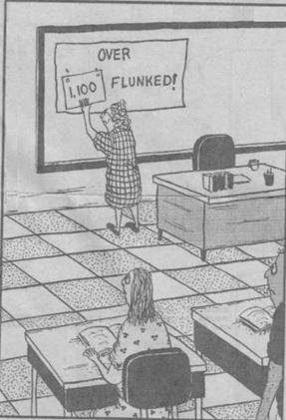

Your grade will be determined by written and oral assignments (50% ), a final test (25%), and attendance (25%).
Make-ups: If you missed an assigned class presentation and want to avoid a ZERO for this part of your final grade, or if you missed a class and do not want your attendance grade to suffer, you can make up by undertaking an additional, equivalent, assignment in consultation with class instructor.
Late Assignments and Re-Writes: All papers submitted on time may be (unless you received an A or A- on the first draft) re-submitted anytime throughout the term (but no later than April. 10, 2007) for a higher grade. In that case, the final grade for that assignment will be the average of the grades for the original and revised drafts. If you submit hard copies, please attach the first instructor-edited draft to the final, clean draft. If you submit electronically, please submit your corrections, in green font, on the same document you received from your class instructor.
Assignments submitted after the due date will be marked down 10%.
Attendance will be graded by hours missed in workshops and plenary sessions: 0 hours missed = A+; 2 hours=A; 4=B+; 8=B-; 12=C-; 14=D; ≥16=E.
Attendance grade is a performance grade, and it does not take into consideration the causes of absence, of arriving late, or of leaving early. Coming in late or leaving early on any day or weekend will be factored into the attendance record. There is no need to advise your instructor in advance of prospective absences and their causes. So if your house caught on fire, your car broke down, and all three of your children got married on the particular day of class, your instructor will be both sad and happy for you—and give you a zero attendance grade for that week. If you miss more than 12 hours of class time, you cannot receive a passing grade in this class. The reason for this is simple: a good part of the learning takes place in class, so, the less you attend (for whatever reason), the less you get out of this class! Also, on any given, you have an option of attending class on either Tuesday or Saturday. We understand that things happen, and that is why we offer a make-up option (submitting extra assignments).

Text: Coursepack sold in class ($12—most of the material is also available online at: http://www.is.wayne.edu/mnissani/20302005/).

Grading Policy
A = Excellent (A equivalent to 4.00 HPA; A- equivalent to 3.67)
B = Good (B+ 3.33 HPA; B 3.00; B- 2.67)
C = Average (C+ 2.33 HPA; C 2.00; C- l.67)
D = Poor (D+ 1.33 HPA; D 1.00; D- 0.67)
F = Not acceptable ( F = 0.00 HPA). “F” replaces the former “E” grade.
I = Requirements not met fully (at least 70% of the work completed with no need to attend further classes). At the end of year, the University automatically converts an "I" into an "F." Extensions past academic one year will no longer be possible.
W = Student-initiated withdrawal from classes in three possible categories: WP (Withdrawal Passing), WF (Withdrawal Failing), and WN (Withdrawal Never Attended). The old “X” grade has been eliminated. Students who do not complete coursework and who do not request a course withdrawal prior to the final exam will receive a failing grade of “F” under the new University-wide policy.

Repeats of Courses: Two rules apply. (1) Students may only repeat the same class twice. To repeat the same class a third time, an advisor must grant approval. (2) Students may only have 3 total repeats of all of their classes. To repeat a fourth class, an advisor must grant approval. Here is an example: a student could repeat the following three separate classes: MAT 1800, ENG 1010, and PHY 2310. An advisor would have to approve the student to repeat a different class.

Grade Appeals: The ISP formal policy applies if a student disagrees with an instructor’s grade (see <http://www.is.wayne.edu/Policies/Grade%20Appeal%20Process.htm)>. The
appeal policy has two steps. First, talk with the instructor to see if the dispute can be resolved informally. If the first step fails, speak to the Department Chair, who will refer the matter to the IS Academic Standing Committee. Students may also consult the WSU Bulletin section on the Ombudsperson.

Policy on Course Conduct
- No cell phones may be used in the classroom. If you need a cell phone for emergencies, put it on “vibrate” or a similar feature and either answer during breaks or leave the room to respond.
- Be considerate of others by placing all trash in appropriate containers and by not carrying on conversations during class.

Academic Success Center (2100 UG Library, 313.577.3165)
This center provides tutoring and supplemental instruction. It can significantly improve your chances of doing well in college.

Special Needs Students
If you are disabled, I shall be eager and happy to help you in any way I can. In addition, the Office of Educational Accessibility Services serves as an advocate for disabled students and helps to secure accommodations. The Office is at the Student Center Building, Room 583, phone: 313-577-1851; Voice: 313-577-3365 (TTY).

Inclement Weather Policy
313-577-5345 or major radio and television stations for WSU closings (that is, cancellation of classes).

Week 1: September 2007

  John Lennon | 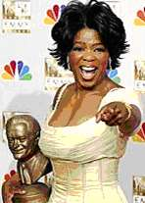  Oprah Winfrey |   Kenn Nesbitt |   Bob Blue

I couldn't imagine a more crucial skill than summarizing; we can't manage information, make crisp connections, or rebut arguments without it. The great syntheses and refutations are built on it.
Mike Rose, Lives on the Boundary, 1989, p. 138
Technical
- Coursepack sale ($12; volunteer treasurer is needed; receipts available)
- Revision of Pipeline’s class roster
- A look ahead: schedule, readings, coursepack, syllabus
- Format: no scared or sacred cows
- How to survive and get the most out of this class
- Activating your e-mail; other computer issues
- Safety, parking, snacking issues

Optional Class Activities

What’s Special about the ISP? (Coursepack, p. 1). A Few Illustrations: “Their Way;” “Falling Asleep in Class” (pp. 2-4)
In-Class Writing Assignment: Oprah Winfrey on education and freedom. Please listen to the CD. In 80-100 words, summarize in writing Oprah Winfrey’s views on education and freedom. Exchange your written work with a classmate for feedback, revise, and hand in your work to class instructor. This is a formal class assignment.
College Preparedness Assessment: This is a formal assignment, aimed at helping us improve overall quality of instruction at the ISP. We will review and grade it right here in class, and give you some advice on what steps you must take to do well in college.
Sharing personal and educational experiences: Who am I? What at am I doing here?
Five levels of interacting with texts: Contextualizing, Summarizing, interpreting, critically evaluating, assimilating:
I. <div align="center">The story of the three little pigs.
II. Caught in a Lie:
These two guys were taking a chemistry class and doing A work. On the weekend before the Monday final they decided to go up to Montreal and party with friends. They had a great time, but with their hangovers and everything, they just couldn’t take the chemistry final. They went to see the professor right after the exam and told him that on the way back from Montreal they had a flat tire, didn’t have a spare, and got back to campus too late for the final. The professor agreed to let them take a make-up test on the following day. They studied hard that night and, at the appointed time, showed up for the make-up final. The professor placed them in separate rooms and handed each a test booklet. To their relief, the first problem—a problem involving molarity and solutions—was easy. It was worth 5 points. Both solved it and glibly turned the page. The rest of the test consisted of a single question: WHICH TIRE? (95 points).
- West African folktale, Kaddo’s Wall (pp. 104-109)
- “Their Way” (Lyrics by Bob Blue, p. 3)

Writing Exercise: Divide into groups. Each group applies in writing just one of levels 2-5 (summarizing, interpreting, critically evaluating, assimilating) to one of the readings above. Each group edits and improves its work, then reads it aloud to the class.
Can Grammar be Fun?: A Game with Thirteen Lousy Sentences (pp. 10-11)

Assignments for next week
Read:</div>
If Not Higher (pp. 12-14)
King David's Crime (pp. 14-15)
→Underlined titles are available online: www.is.wayne.edu/mnissani/20032005/readings.htm

Study:
Read rules for using the apostrophe (pp. 15-17 or 127), and be prepared for next week’s competition. The competition will take place in two rounds. The first round will involve individual sections. The second round will involve a “Saturday Afternoon Live” (week 4) competition among the finalists from the different sections.

Write:

Apply the five levels to either If Not Higher or to King David’s Crime (300<n<800 words).
Reminder: By writing we mean: Read the story as many times as you need to remember it well. Then, close the book and write from memory. When done, you can compare your version to the book’s for accuracy. If your instructor is under the impression that you wrote your assignment with an open book, the assignment will be returned to you unread and recorded in the grade book as a missing assignment.

→Next workshop: bring a Bible and $12 (cash) for the Coursepack (if you didn’t buy it already)

→Monday, January 22, 2006: Census Day: Last day to officially withdraw from classes and receive 100% tuition refund. If you withdraw a day later, you get nothing back.

Week 2:

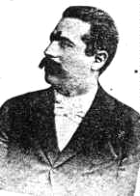  Y. L. Peretz | 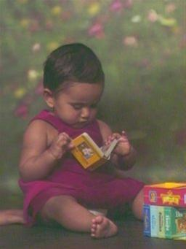  Nishi Tripathi | 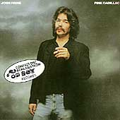  John Prine

Optional Class Activities
Review of previous workshop and preview of today’s workshop.

Five Levels. Students divide into small groups and, following group discussions, present to class one of the five levels of either "If Not Higher" (pp. 12-14) or "King David's Crime" (pp. 14-15).

Class Apostropher Competition

Creative Thinking in Action: Divide into groups and try to solve the following problem. You have 1023 single dollar bills and 10 envelopes. Place the money in the envelopes, then seal and label the envelopes. Place the singles in such a way that, if anyone asks you for any sum of money between $1 and $1000, you can give that sum by handing them between 1 and 10 envelopes.

Digging Deeper into Texts: Your Flag Decal (John Prine; pp. 17-18)
→Online: Music Lyrics Video
We often listen to songs or watch movies without giving them the attention they deserve. Occasionally however, we pause, listen—and really understand. To illustrate this point, let’s divide into small groups and listen to a Vietnam-era song, enjoy it, answer the following questions, and explain our answers:

- What kind of magazine is Reader’s Digest?
- Why is it called digest?
- Who does it belong to?
- Who is this guy, the narrator of this song?
- Can the narrator think for himself?
- Does the narrator believe his country’s propaganda system?
- This is an old song: Has anything changed since?
- The flags caused the narrator’s death, blocking his view. What is the meaning of this?
- Prine says that “Jesus don’t like killing, no matter what the reason for.” Is this good English? What’s the point of using substandard English?
- What is the evidence, in St. Matthew, for Prine’s claim that Jesus is opposed to any killing, period?

Assignments (due 3 weeks from now—next week we’re in the computer lab and the week after that is a Saturday plenary session):

Read:
Dr. Carson, Doctor and Leader (pp. 18-19)
The Library Card (Wright, 19-26).
The Good Example (Riva Palacio, 26-27)
My Father (Asimov, 28-30)
In Praise of Literacy (Sagan, 31-32)

Prepare a class presentation (2-6 minutes):
Tell a story of some kind. We are surrounded by stories, every day of our lives. You tell your spouse a tale from the workplace. A coworker tells you a joke. An ISP counselor told you a real interesting story about an ISP 2030 class instructor. So, anything goes, as long as it is 2-6 minutes in length, inoffensive, interesting, and unfamiliar (we have all heard about Snow White). Imagine that you are a story teller, and try to tell it as well as you can.
Rules:
- Your presentation must be spoken, not read
- Please submit a written outline of your presentation to class instructor before class begins. (If late, you lose 50% of the credit for this particular assignment)
- You’ll also need to be prepared to tell your story (2-6 minutes) to the class. However, owing to time constraints, only 7 people—selected at random from among all class participants—will actually get a chance to tell their story to the class.
- If you are too anxious about speaking in public, you might want to give it a try anyway. But you don’t have to. If you submit an outline on time, you’ll get full credit for this formal class assignment.
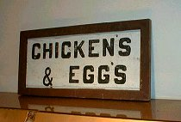  Apostrophe butchery in real life: Exhibit #1 | 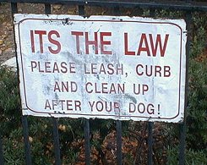  Apostrophe butchery in real life: Exhibit #2

→Next class is at a computer instructional lab, location to be announced by class instructor

Week 3: Computer Workshop

Please consult and submit the Week 3 File as an attachment (file is available at: http://www.is.wayne.edu/mnissani/20302005/Wk3.htm). For a hard copy of that file, see pp. 41-43 of your coursepack).

→Reminder: There is no regular session next week. Instead, class is Saturday, 3, 9-5, 150 General Lectures, WSU Campus

Week 4: 9:00 a.m.-5:00 p.m.
September 29, 2007, 150 General Lectures Bldg.
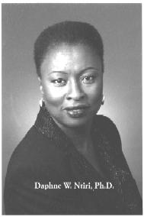 |  | 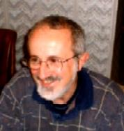 | 
Dr. Daphne Ntiri | Dr. Caroline Maun | Dr. James Michels | Dr. Fran Shor

➔Please sign the attendance sheet (your section instructor will have it) when you come in

9:00: Introductory Remarks: Welcome, Today's Plan, What’s special about the ISP? (Daphne Ntiri)
9:20: Class Apostropher Competition: Final Round (Anderson; Nissani)

→Formal assignment: Please submit now your apostrophe assignment to your class instructor

10:05: Break
10:20: Reading and Writing Proficiency Assessment and Self-Assessment (Caroline Maun)
12:20: Lunch

1:50: “A Dream Deferred:" Power of Interdisciplinarity (Jim Michels)
2:30: Applying Interdisciplinarity to understanding the Third World (Dr. Daphne Ntiri)
3:10: Break
3:30: Do Dolphins, Chimpanzees, Elephants, and Other Animals Think? (Moti Nissani)
4:10: Break
4:20: Formal, graded, in-class, writing assignment (see below).
4:45-5:00: What Have We Learned in School Today? Next Workshop Announcements. Farewells (Anderson)

Graded Writing Assignment (submit to class instructor, 5 p.m.):
- Please identify and explain one unique feature of the ISP (Ntiri). (>20 words)
- What are the 4 basic rules for using and not using the apostrophe? Illustrate each part of your answer (Nissani)? (>50 words)
- Summarize “A Dream Deferred” in your own words (closed book please; Michels). (>20 words)
- Name 3 disciplines needed to understand contemporary events in the Third World (Ntiri) and give 3 examples how each one of the 3 disciplines can be used. (>50 words)
- Recount three experiments suggesting that animals do not think (>40 words)
Week 5:

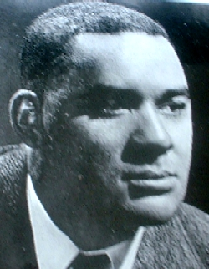  Richard Wright | 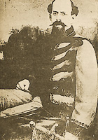  Vicente Riva Palacio | 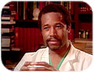  Ben Carson | 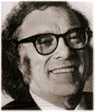  Isaac Asimov |   Carl Sagan

Optional Class Activities
Review and preview.
Class presentations: Story Telling (7 randomly selected presentations).
Unfinished business from Weeks 1-3.
Class discussion and preview of next week’s in-class writing assignment: A comparison of Carson’s, Wright's, Riva Palacio's, Asimov's, and Sagan’s views of education. These 5 writers lived in different times and places. Are their views of education radically different? What would each author say about the education you received as a child? As an adult? The education you are presumably receiving right now?
Old Main (Wayne State’s most beautiful building)

Interacting with Comics

I. The Dumb Biophysicist
II. Latinos in the USA
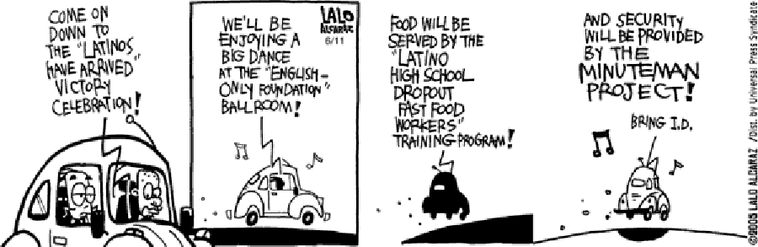

Week 6:

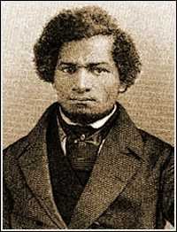  Frederick Douglass | 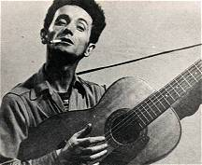  Woody Guthrie

Optional Class Activities

Review and preview.

Essay Writing Workshop
In this workshop, we shall write together the first draft of your Learning Essay. The Assignment is this: Compare and contrast your educational experiences and dreams to the educational experiences and dreams depicted in Richard Wright's "The Library Card" (Wright, pp. 19-26) and at least one of the following readings: Carson (18-19), Riva Palacio (pp. 26-27), Asimov (p. 35), or Sagan (31-32). Note: By dreams we mean the types of educational realities that they would like to see, both for their own personal education and for society as a whole. (length: 600<n<1500 words). By workshop’s end, submit the first draft of your learning essay. This is a formal class requirement.

Required Essay Outline:
- Title of Essay
- Introduction (Note: The first sentence must start: In this essay I’m going to . . .)
- Describe one relevant (similar to Wright’s, different from Wright’s, reminiscent of Wright’s) educational experience—a specific episode—from your own life. (Note: By specific episode we mean something like that: Something happened to you while you were in 2nd grade, just before Christmas; OR: something that happened to you in your first year in college, in Prof. Washington class)
- The educational experiences of the "Library Card." Note: don’t retell the story; focus instead on the learning aspects of Wright’s account.
- Compare and contrast this episode to a comparable episode in Wright’s narrative.
- My educational dreams: The education I'd like everyone on this earth to have.
- My educational dreams: What I personally hope to achieve on the educational front.
- Conclusion: Putting it all together.

Questioning our Answers: This Land is your Land
Perhaps the greatest block to intellectual, moral, and spiritual progress is our inability to question our beliefs. Deep down we say to ourselves: Other people, sure, we can see that they could be wrong. But me wrong? Me brainwashed? With training, most people can partially overcome this universal human failing. Remember: The crow’s nest is a frightening place to climb up to or perch in—but the view is fantastic.

- Listen to the first stanza of this song, music and words.
- Now kindly hand your instructor a written answer: What’s this familiar song about? What does it celebrate?
- A review of written answers
- Listen to / read (class handout) the entire song.
- What is this song really about?
- Prepare a class presentation, focusing on these questions:
  - Was my written answer wrong?
  - Why didn’t I know what this popular song is REALLY all about?
- Class discussion: Lessons from this exercise

Assignments for Week 8 (two weeks from now)

Read one or more of the following (your instructor will specify which):
- Interdisciplinarity: What, Where, Why? (64-68)
- The Stub Book (57-59)

Submit: Learning Essay (if you did not submit it in class).

Week 7:

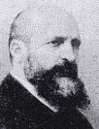  Pedro Alarcón | 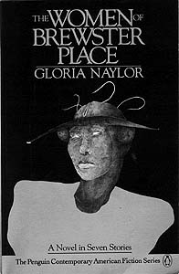 | 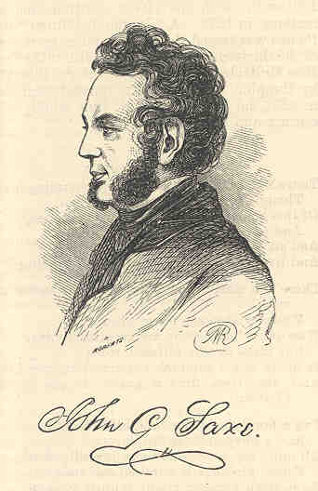  John Godfrey Saxe
Optional Class Activities

Review and Preview.

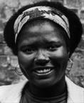  Gloria Naylor | Wonders of Books on Tape (note: We’re deliberately using books on tape for this assignment, not a movie—why?): Kiswana Browne (see also pp. 91-98)  Discussion topics:  - Who is right about the name change, Kiswana or her mother? Explain.  - Who is right about fighting for one’s people, Kiswana or mama? Explain.  - What does it mean, fighting for one’s people—aren’t we all brothers and sisters?  - Does this story bring to mind a personal experience with a parent or child?  - In the story, Kiswana understands, perhaps for the first time, that her mother is a fellow human being. Which trivial episode helps her see their common humanity?

Hands-On Writing Workshop: Interdisciplinarity


Goal: if you pay attention, you may not be able to pronounce interdisciplinarity when we are done, but you sure will be able to explain your major to your spouse (who might otherwise have doubts about your whereabouts, one night a week + two Saturdays!), parents, children, grandchildren, friends, coworkers, and supervisors.
To do this, we shall, together, write the following assignment. Note: this is a formal, graded, class assignment. You will write your answers and then submit them before we say goodbye tonight. If you miss class, or leave early, you must still submit the answers to all these questions by next week.
Before every question, you may wish to consult pp. 64-68 and 57-59. But, when you start writing, remember, the book must be closed!

- What is a discipline?
- Please give 3 examples.
- What is interdisciplinarity (IDS)?
- Give one example.
- Where do you find interdisciplinarity? Find the 4 contexts in the article (pp. 64-65). Now, you need to demonstrate comprehension of what you have been reading. So, in each of the 4 contexts, first give the name of that context. Next, define it. Next, give an example of your own. (Why do we insist on an example of your own? Because that tells us (and you) that you understood the material).
- List, explain, and illustrate 5 advantages of interdisciplinarity.
- Defend the statement: The Stub-Book can be seen as an illustration of interdisciplinary breakthrough.
- Defend the statement: To really understand Alarcón’s story (57-59), we must know something about the disciplines of psychology, geography, law, literature—to mention a few.

→Reminder: There is no regular session next week (Feb 27 or March 3). Instead, class is Saturday, March 3, 2007, 9-5, 150 General Lectures, WSU Campus

Week 8: Sat. 9:00 a.m.-5:00 p.m.
March 3, 2007, 150 General Lectures Bldg.

 |  | 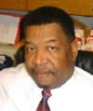 | 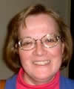
Andre Furtado | Nancy McQuaide | Howard Finley | Linda Hulbert

➔Until 12:30 today coffee, bagels, and other goodies will be available outside the lecture hall. All proceeds from this sale go to the ISP's Women Scholarship Fund.
➔Please sign the attendance sheet twice: when you arrive and just before you leave
→ You are expected to take notes on EVERY presentation you listen to today. Your notes should attempt to capture the basic points of each presentation, and should be at least 5 hand-written pages in length (or, if you submit them online, at least 2 double-spaced pages). This is a formal, graded, class assignment which will be taken in consideration in deciding your final grade. Please submit your notes to your class instructor at the end of this plenary session, either electronically or as hard copies.

9:00: Sign in. Welcome and Introductions (Darnell Anderson)
9:05: Tips for WSU's Math Proficiency Examination (Andre Furtado)
10:50: Break
11:05: 11:40: ISP Student Services and You (Convener: Howard Finley)
12:30-1:30: Lunch and Optional Individualized Counseling Sessions
1:30: Reminiscences, Reflections, Questions, Answers: ISP Alumni, Seniors, and Lifelong Aficionados (Darnell Anderson, Nancy McQuaide, Dwight Thomas).
2:20: Break
2:30: Interdisciplinary Analysis of Witches' Curse (Linda Hulbert)
4:30: Looking back and ahead; farewells (Anderson, Nissani)
4:40-5:00: Revise and submit your notes. Sign Out.


Week 9:

 | There is no frigate like a book  To take us Lands Away--  Emily Dickinson | 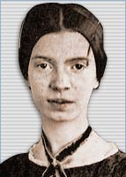

Optional Class Activities

Review of previous week and a preview of this workshop.
One more illustration of interdisciplinarity: Andean and Western Music

Critical Thinking in Action II. We still pride ourselves on being a free country, and we trace our freedom to certain historical events. This workshop will explore these beliefs, and attempt to trace our love of freedom to its true historical origins.
- What do we mean by freedom?
- A taste for freedom must be acquired, or re-acquired. Where did we, Americans, acquire this taste? Which men and women contributed most to this concept.
- Now let’s read aloud, together, a recent book review (pp. 141-143). What is the author’s viewpoint on the origins of our freedom? Does his viewpoint make sense? If so, how come no one told it to us before, in our schools, media, government publications?

Geography Fun Competition (pp. 144-145)

Read by Next Week: Coursepack, pp. 68-76.

Week 10:

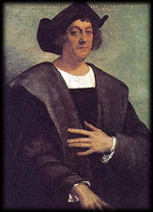  Christopher Columbus |   President Hugo Chavez |   Leonard Pitts, Jr.

Optional Class Activities

Review and preview.

Writing Workshop: Should I celebrate Columbus Day?
- Background material: pp. 68-76.
- We shall write this essay together, following instructions of p. 68 (or at: http://www.is.wayne.edu/mnissani/20302005/Columbus.doc).
- When done, please submit your paper to class instructor: This is formal class assignment

Class Discussion: Offer a summary of, critical evaluation of, and a personal response to, Pitts’ views on African-Americans and gays (pp. 76-77).

Assignments for Next Session:

Read: "Marriage is a Private Affair" (pp. 78-81) and "Contents of the Dead Man's Pockets" (81-90),

Prepare a class presentation (2-6 minutes) on either one of these topics:

Tradition or Common Humanity: Was Okeke (Nnaemeka's father in "Marriage is a Private Affair") right or wrong in disowning his son?
OR
Leisure or Pleasure: Should you seek advancement on your job, or spend some quality time with loved ones?
OR
Should I celebrate Columbus Day?
.
Rules:
- Your presentation must be spoken, not read
- Please submit a written outline of your presentation to instructor before class begins.
- You’ll also need to be prepared to talk (2-6 minutes) to the class. However, owing to time constraints, only 7 people—selected at random from among all class participants—will actually get a chance to tell their story to the class.
- If you are too anxious about speaking in public, you might want to give it a try anyway. But you don’t have to. If you submit an outline, you’ll get full credit for this formal class assignment.

Week 11:

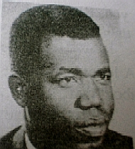  Chinua Achebe | 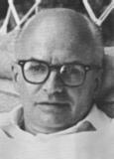  Jack Finney  (1911-1995)

Optional Class Activities

Review and preview.

Individual oral presentations on topic (2 min.):
- Tradition or Common Humanity: Was Okeke (Nnaemeka's father in "Marriage is a Private Affair") right or wrong in disowning his son?
OR
- Leisure or Work: Should you seek advancement on your job, or spend some quality time with loved ones?
OR
- Should I celebrate Columbus Day?

Analysis of Contents of the Dead Man's Pockets (p. 81-90):
    - Five levels
    - Artistic features
    - Interdisciplinary features

Read for next week: The Fight (pp. 99-103)

Week 12:

An Iceberg, New Foundland, Canada

Optional Class Activities
In-class writing workshop. You’ll be writing a first draft of your essay in class and submit the final draft by next week. The essay itself will have 400 or more words: a title + 9 paragraphs. The essay will respond to Richard Wright’s “The Fight” (pp. 99-103), relying on this outline:

- Title
- Intro (In this essay . . .)
- Succinct summary of Wright’s sad tale (Note: We don’t want pages and pages, just enough to understand what happened)
- Morals of this tale
- What does this tale say about human nature? Explain.
- What does it say about conditions in the South then?
- Would you have the courage to tell such a story about yourself? Why or why not?
- Why are the two African-American protagonists estranged at the end?
- Compare “The Fight” to something that happened to you (if you can’t think of anything similar, then compare it to something that happened to someone you know or heard about, or something you saw in a movie).
- Personal reflections and conclusion

Science in the News: Icecaps and hurricanes: the proof of climate change (pp. 110-112; also available at: http://www.is.wayne.edu/mnissani/20302005/icecaps.htm)

Discussion questions:
- The author documents climate change through several examples. Describe and explain each example.
- Can you come up with additional examples showing that climate change has arrived?
- Do you agree with the author that climate change is real? Why?
- What are your personal strategies for dealing with climate change?
- Can we do anything about climate change?

Week 13:

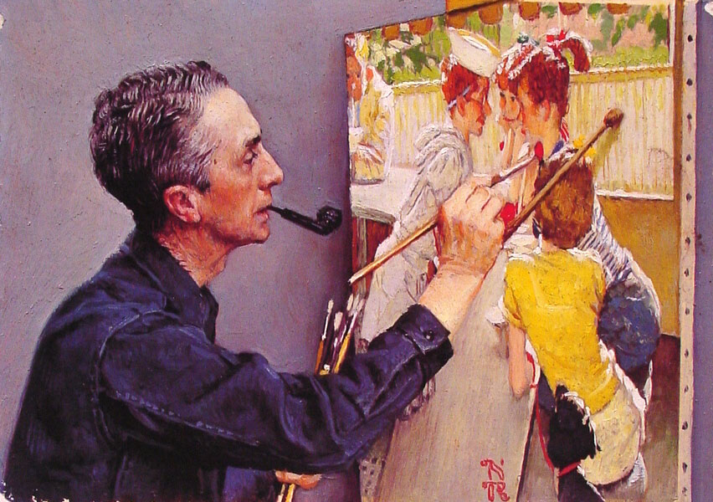  Norman Rockwell: Self-Portrait (of himself painting a picture) |   Julia Sweeney |   The Eagles
Optional Class Activities

Review and Preview.

The A, B, C of Text Interpretation
    - What’s the moral of Norman Rockwell’s painting, “The gossips?”(p. 56)
    - Hotel California (p. 112). Sometimes, though, interpretation is difficult. In such cases, we may consult the author, someone else—or let our imagination soar! Let’s listen to this great song, and then try to figure out: What are they talking about?

Film: Shall We Dance or Bread and Tulips or Mad Hot Ballroom
- Exploring the film: A class discussion
- In-class assignment (to be submitted at end of class or next week, following extensive class discussion): Applying the five levels to the film.

Summarizing, Critically Evaluating, and Assimilating Julia Sweeney’s “Letting Go of God.”
Here, according to program notes, Julia Sweeney, an ex-Catholic, tells (in 30 minutes) how her faith began to crack after reading a most alarming book—the Bible. Please take notes while listening to the play. You may then be asked to contribute to a distillation of Sweeney’s detailed argument. Here we imagine that we want to retell in our own words her argument as vividly and convincingly as we can. Once we’re clear about her reasons for letting go of God, we’ll try to find the strengths and flaws of her position (e.g., Is her argument a good one? Why? Is it a bad one? Why? Is it a touching essay? Is she sincere? Does she do a good job, or is she a bad reader/thinker? Any other good points? Bad points?). Our next topic will be personal: The meaning of Julia Sweeney’s play to each one of us.

Next Session's Assignments:
Read: "A Painful Case" (pp. 118-122)
Write: An essay (500<n<1,000 words) on: "Unlike (or like) Joyce, Naylor, and Finney (choose and discuss at least one of these readings), this is how I plan to lead the rest of my life."

Week 14:

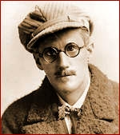
James Joyce
Optional Class Activities
Review and preview.
Improvised class presentations on any topic touched upon in this class.
Hands-on IDS Analysis: A Major Item of this Week’s News.
Unfinished business.
A preview of ISP courses.
Looking back on ISP 2030: What have we learned this past semester?
Happy Christmas (John Lennon): Lyrics Video: How is the song different from Walmart’s Christmas songs?
Student Evaluations of Teaching.

Week 15: December

Closed-book final examination on questions taken from among the following:
ISP 2030: Requirements for Second Half of Semester

The last written assignment you need to submit in this class is the Learning Essay. Beyond the second plenary session, we shall rely on the skills we have developed on the first part, further develop our reading and note-taking skills, and apply these skills to a final, closed book, closed cell phones, closed laptop, closed everything, examination during finals week. Thus, your final grade in this class will be based on the following:
- Attendance: 25%
- Assignments for first part of the term (including Learning Essay): 35%
- Final test: 40%

You can take this final test on either one of the following two dates:
  - Saturday, April 28, 9:35-11:35, 215 State Hall
  - Tuesday, May 1, 6-8, 126 Cohn

Questions for the Final Test will be taken from the following:
- A sampler of grammar questions from assignments and tests you have already taken and which can be found in your coursepack: a. pp. 10-11 (a-m), b. 13 Lousy Sentences (p. 10), c. Apostrophe game (p. 147)
- Questions 1-11 from the Geography Fun Competition (144-5)
- Retelling and/or interpretation of The Library Card (p. 19), The Good Example (p. 28), The Gossips (p. 56), two comics (p. xvi), Kiswana Browne (91), Hotel California (112), Civil War between Gays and Blacks (76-7), Marriage is a Private Affair (78), Contents of the Dead Man’s Pockets (81)
- Critically evaluating Julia Sweeney’s “Letting Go of God”
- Defining interdisciplinarity (64)
- Explaining the “intellectual, social, and practical problems” advantage of interdisciplinarity (pp. 66-7), using the greenhouse effect as a key example.
- Describing and explaining: What’s the interdisciplinary point in the “The Stub Book”? (57).
- Solving: a. Creative thinking in action (puzzle, p. xi), b. Hanoi puzzle (42), c. Puzzles 1 and 5 (123-4)
- Writing a well-informed essay, following the exact same outline you used before: Should I Celebrate Columbus Day? (68)
- The following questions regarding “An Inconvenient Truth:” 1. Describe and explain 4 distinct present impacts of climate change. 2. What are, according to Gore, the three causes of humanity’s collision with Earth. Describe and explain. 3. What are the three misconceptions about climate change? Describe and explain.

Back to ISP 2030’s Welcome Page

