<div align="center"><div align="center"><div align="center"><div align="center">
<big>ISP 2030: Interdisciplinary Studies Seminar  &</big>  ISP 3080: Capstone Conference<big>  Program of Interdisciplinary Studies </big>  Wayne State University  Winter 2008 (01/12 - 04/26)  →Please visit this class online: www.is.wayne.edu/mnissani/20302005/ | 

“If you don’t have time to read, you don’t have the time (or the tools) to write. Simple as that.”—Stephen King

The Stephen King quote above, called an “epigraph,” defines the teaching philosophy of the ISP 2030/3080 team. Reading is at the base of an essential triangle of skills for success in academic study, professional work, and your personal life. Reading, writing, and critical evaluation are inter-related acts. In keeping with this philosophy, the team has prepared a packet of appealing readings that are both cross-cultural and cross-disciplinary. Our teaching methodology, or “pedagogy,” likewise employs activities that will help students hone skills of reading comprehension, structured writing, and critical evaluation. The readings are grouped for the most part into the following themes: the nature of good education, life changes and choices, the African-American experience, women, science, and critical thinking. Development of the related skills of reading, writing, and critical thinking will give you confidence in your own intellectual powers and a respect for the integrity of higher education, the life of the mind, curiosity, and a love of reading, in addition to cultivating pertinent skills of computer use and interdisciplinary thinking.
To put it slightly differently: the focus of this class is not on specific content, but fostering curiosity and the development of such college-related skills as reading, writing, critical and holistic thinking, and computer proficiency. To do this, we’ll rely on a cursory introduction to a few unrelated aspects of the world of learning. This class, as well, provides a comfort zone for beginning students in the Department of Interdisciplinary Studies while challenging them to strive for new levels of competence.
Locations and Maps
To view an online map of all instructional locations, please go to: www.campusmap.wayne.edu/index.php.
- To find a specific campus building, its address and picture, left-click “Building,” then click the building you are looking for (e.g., State Hall, General Lectures Bldg, Cohn, State).
- To find a specific off-campus building, its address and picture, left-click “Satellite Campuses” and then left-click the center you are looking for (e.g., Macomb, Wayne County Center).
- You can similarly find the location of any WSU department, college, parking lot, and library.
Times & Locations
This course is comprised of 12 3-hour workshops and 2 8-hour Saturday sessions:

→On 12 sessions, class meet at 113 State Hall, Saturday, 10:00 a.m.-1:00 p.m.

. But, on two Saturdays we meet at a different location and have a much longer class:

→Saturday, 10:00-6:00 p.m. February 2, 2008, Lab A, First Floor, Undergraduate Library, WSU main Campus
→Saturday, 10:00-6:00 p.m. March 1, 2008, Lab A, First Floor, Undergraduate Library, WSU main Campus

Contact Information for Class Instructor
Moti Nissani
Room 4109, Department of Biological Sciences
E-mail: aa1674@wayne.edu
Homepage: www.is.wayne.edu/mnisani/
Tel.: 313.577.3524
Office Hours: To be announced

Text: Coursepack sold on or before class ($13 CASH—some readings and additional materials are available online at: http://www.is.wayne.edu/mnissani/20302005/).

Useful Webpages:
- Class Webpage: www.is.wayne.edu/mnissani/20302005/
- Wayne State University: www.wayne.edu/
- Pipeline: http://lumprod.wayne.edu/cp/home/loginf
- Library Catalogue: http://elibrary.wayne.edu/

Course Description and Objectives
These two companion classes (ISP 2030/3080) will introduce you to Wayne State University and to Interdisciplinary Studies. They will offer a very small class (not more than 15 students) and create a comfort zone for (re)entry into college. These classes will also enhance your reading, writing, and public speaking skills; serve as an invitation to fields as diverse as ecology and Nigerian literature; cultivate an appreciation for divergent cultures, customs, and ways of thinking; prepare you for WSU’s Math proficiency examination; and enhance your critical thinking, computer, and internet skills.
This class will place particular emphasis on reading. Reading well can expand our horizons, liberate us, and safeguard our well being. It gives us more real choices and protects us from scoundrels, charlatans, and psychopaths. Reading well should occupy center stage in any decent educational program, kindergarten to Ph.D. But, what now is called education is often dull and authoritarian. For instance, many of us were made to memorize the multiplication table, leaving us to figure out on our own what multiplication is and what it is good for. It is not easy to break away from this stifling authoritarianism, but we can at least try by:
- Relying on the guided-discovery approach, which is based on the idea that we better understand things we discover ourselves.
- Learning interactively. We can’t possibly assimilate a 3-hour lecture. We learn by interacting with the material, listening to many people, talking ourselves.
- Discussing things that we are naturally interested in, that are of some contemporary interest, and that are relevant to our own lives.
- Challenging our beliefs. We’ll gladly answer your questions, if we happen to know the answers. But, more often than not, we’ll question your answers. This is our conception of good teaching—helping you escape the box. (Our sincere apologies if anything we say, or imply, or ask you to read, offends you or makes you uncomfortable. We’re only asking you to understand—not accept—alternative ways of seeing things).

Two Writing Rules
There are two cardinal rules for all take-home and in-class writing assignments; both rules are designed to bring out and sharpen your own voice:

Closed Book Rule. Each and every writing and speaking assignment in this class must follow the closed book rule. For example, by summary of a short story we mean: Read the story as many times as you need to remember it well. Then, close the book and retell that story in your own words, the way you remember it. When done, and only when done, compare your version to the original for accuracy. Or, to take another example, by interpretation of a film we mean: watch the film and explain in writing the point that the screenwriter and director are trying to make, but do not consult the internet for somebody else’s opinion about that film.

Eighth-Grader Rule. Your main task, in each and every assignment, is to convince the reader or listener that you know and understand what you are talking about. To accomplish this goal, paradoxically, you must imagine that you are writing all assignments for an 8th grader who knows and understands nothing about the subject. So, use words that come naturally to you. Don’t try to impress, but to communicate and explain.
</div>
Plagiarism Advisory


The whole idea of going to college is for you to assert yourself, speak with your own voice, present your own views, bring your pertinent life experiences to bear on the topic or project you chose, make mistakes and learn from them. Obviously, you will obtain a great deal of information and opinions from others, but these will only be minor bricks in the edifice that you will build. That means that you can’t simply take someone else’s words or ideas and call them your own. When the words are someone else’s, you put them in quotes and give the source (see Documenting Scholarly Essays, pp. 131-133). You always write with closed books, closed internet, closed everything. When the ideas are someone else’s, you give that person credit. We are happy to work with people who are still searching for their authentic written voice, and we can help them find that voice—but only if they want to find it.

Grading
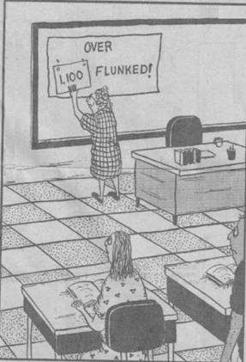

Your grade will be determined by two Midterms (25% each; given on 10:30 a.m, Feb. 2 and March 1), and on a final (10:30 a.m., April 26, 2008).

Attendance:
- If you punctually (never miss a class, never come in late, never leave early) attend all classes, a letter grade will be added to your final grade (e.g., instead of D, you’ll get a C).
- If you miss 3 hours or less (coming late or leaving early count as one missed hour at least), half a letter grade will be added to your grade.
- If you miss more than 12 hours of class time, REGARDLESS of reasons, you must withdraw from this class. Please note that the weeks of February 2 and March 1 are counted as 8 hours each; other weeks are counted as 3 hours. Please note as well that this is a Program Rule—I cannot change it.

University Grading Policy
A = Excellent (A equivalent to 4.00 HPA; A- equivalent to 3.67)
B = Good (B+ 3.33 HPA; B 3.00; B- 2.67)
C = Average (C+ 2.33 HPA; C 2.00; C- l.67)
D = Poor (D+ 1.33 HPA; D 1.00; D- 0.67)
F = Not acceptable ( F = 0.00 HPA). “F” replaces the former “E” grade.
I = Requirements not met fully (at least 70% of the work completed with no need to attend further classes). At the end of year, the University automatically converts an "I" into an "F." No extensions beyond one academic year are possible.
W = Student-initiated withdrawal from classes in three possible categories: WP (Withdrawal Passing), WF (Withdrawal Failing), and WN (Withdrawal Never Attended). The old “X” grade has been eliminated. Students who do not complete coursework and who do not request a course withdrawal prior to the final exam will receive a failing grade of “F.”

Repeat of Courses: This course is being offered for the last time at Wayne State University and cannot be repeated or re-taken in the future.

Appeals: If you are unhappy with your final grade, you can appeal it by contacting: Victoria Asmar Anderson, Ombudsperson, 798 Student Center Building (E-mail: aa9984@wayne.edu; Tel: 1 313-577-3487).

Policy on Course Conduct
- No one has to agree with anyone about anything, but we are going to treat everyone in this classroom, and their views, with dignity, respect, and an open mind.
- No cell phones may be used in the classroom. If you need a cell phone for emergencies, put it on “vibrate” or a similar feature and either answer during breaks or leave the room to respond.
- No laptops may be used while class is in session.
- Be considerate of others by placing all trash in appropriate containers and by not carrying on conversations during class.

Academic Success Center (2100 UG Library, 313.577.3165)
This center provides tutoring and supplemental instruction. It can significantly improve your chances of doing well in college.

Special Needs Students
If you are disabled, I shall be eager and happy to help you in any way I can. In addition, the Office of Educational Accessibility Services serves as an advocate for disabled students and helps to secure accommodations. The Office is at the Student Center Building, Room 583, phone: 313-577-1851; Voice: 313-577-3365 (TTY).

University-Wide Class Cancellation Policy
If you suspect that a class may be cancelled (e.g., a snow storm, grade-5 hurricane, nuclear war) call 313-577-5345 or consult major radio and television stations).

Week 1: Saturday, January 12, 2008

  John Lennon | 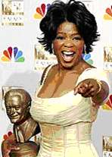  Oprah Winfrey |   Kenn Nesbitt | 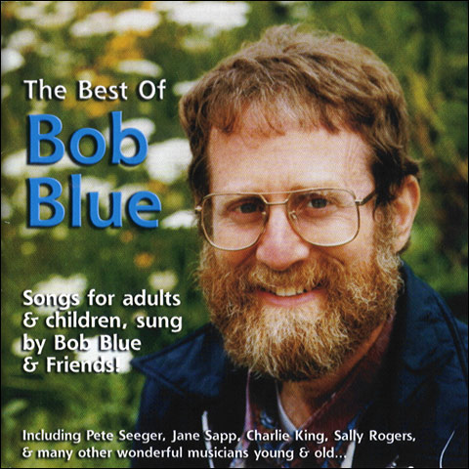  Bob Blue

I couldn't imagine a more crucial skill than summarizing; we can't manage information, make crisp connections, or rebut arguments without it. The great syntheses and refutations are built on it.
Mike Rose, Lives on the Boundary, 1989, p. 138
Technical
- Coursepack sale ($13; volunteer treasurer is needed; receipts available)
- Revision of Pipeline’s class roster
- A look ahead: schedule, readings, coursepack, syllabus
- Format: Getting outside the box
- How to survive and get the most out of this class
- Activating your e-mail; other computer issues
- Safety, parking, snacking

Teaching out of the box: A Few Illustrations: “Their Way;” “Falling Asleep in Class” (pp. 2-4)
In-Class Discussion: Oprah Winfrey on education and freedom. Please listen to the CD. In 80-100 words, summarize in writing Oprah Winfrey’s views on education and freedom.
Sharing personal and educational experiences: What am I doing here?
Five levels of interacting with texts: Contextualizing, summarizing, interpreting, critically evaluating, assimilating:
I. <div align="center">The story of The Crow and the Pitcher.
II. Caught in a Lie:
These two guys were taking a chemistry class and doing A work. On the weekend before the Monday final they decided to go up to Montreal and party with friends. They had a great time, but with their hangovers and everything, they just couldn’t take the chemistry final. They went to see the professor right after the exam and told him that on the way back from Montreal they had a flat tire, didn’t have a spare, and got back to campus too late for the final. The professor sympathized and agreed to let them take a make-up test on the following day. They studied hard that night and, at the appointed time, showed up for the make-up final. The professor placed them in separate rooms and handed each a test booklet. To their relief, the first problem—a problem involving molarity and solutions—was easy. It was worth 5 points. Both solved it and glibly turned the page. The rest of the test consisted of a single question: WHICH TIRE? (95 points).
- West African folktale, Kaddo’s Wall (pp. 104-109)
- “Their Way” (Lyrics by Bob Blue, p. 3)

Can Grammar be Fun?: A Game with Thirteen Lousy Sentences (pp. 10-11)

Read by next week:
- Coursepack, </div>pp. 4-7 (http://www.is.wayne.edu/mnissani/20302005/5Levels.doc and http://www.is.wayne.edu/mnissani/20302005/readings.htm), If Not Higher (pp. 12-14), King David's Crime (pp. 14-15)
- Read rules for using the apostrophe (pp. 15-17 or 127) and be prepared for next week’s first apostrophe competition.

→Underlined titles are available online: www.is.wayne.edu/mnissani/20032005/readings.htm

→Friday, January 18, 2008: Census Day: Last day to officially withdraw from classes and receive 100% tuition refund. If you withdraw a day later, you get nothing back.

Week 2: 1/19/08

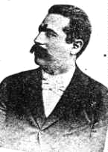  Y. L. Peretz |   Nishi Tripathi | 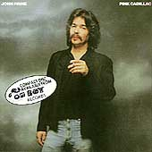  John Prine

Review of previous workshop and preview of today’s workshop.

Applying the 5 Levels: “The Zax” (http://youtube.com/watch?v=spOIbEJmH4Y)

Reading Levels. Students divide into small groups and, following group discussions, present to class context, summary, and interpretation of either "If Not Higher" (pp. 12-14) or "King David's Crime" (pp. 14-15).

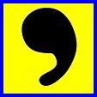
Class Apostropher Competition

Apostrophe Rules:

Don’t use an apostrophe with:

Plurals: Where the boys are; The Body Snatchers
- 3rd person: She walks; the earth moves
- Possessives like: its, yours, ours, theirs

Use Apostrophe with:
- Ordinary possessives: Cat’s Cradle; the 2 Cats’ hiding place
- Contractions: It’s hot; She wouldn’t; I ain’t marching anymore; Don’t worry, be happy

Creative Thinking in Action: Divide into groups and try to solve the following problem. You have 1023 single dollar bills and 10 envelopes. Place the money in the envelopes, then seal and label the envelopes. Place the singles in such a way that, if anyone asks you for any sum of money between $1 and $1000, you can give that sum by handing them between 1 and 10 envelopes.

Digging Deeper into Texts: Your Flag Decal (John Prine; pp. 17-18)
→Online: Music Lyrics Video
We often listen to songs or watch movies without giving them the attention they deserve. Occasionally however, we pause, listen—and really understand. To illustrate this point, let’s divide into small groups and listen to a Vietnam-era song, enjoy it, answer the following questions, and explain our answers:

- What kind of magazine is Reader’s Digest?
- Why is it called digest?
- Who does it belong to?
- Who is this guy, the narrator of this song?
- Can the narrator think for himself?
- Does the narrator believe his country’s propaganda system?
- This is an old song: Has anything changed since?
- The flags caused the narrator’s death, blocking his view. What is the meaning of this?
- Prine says that “Jesus don’t like killing, no matter what the reason for.” Is this good English? What’s the point of using substandard English?
- What is the evidence, in St. Matthew, for Prine’s claim that Jesus is opposed to any killing, period?

Read by Next Week:
The Library Card (Wright, 19-26).
The Good Example (Riva Palacio, 26-27)
In Praise of Literacy (Sagan, 31-32)

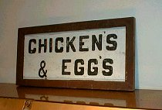  Apostrophe butchery in real life: Exhibit #1 | 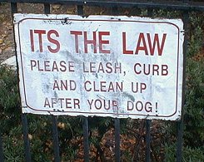  Apostrophe butchery in real life: Exhibit #2

Week 3: 1/26/08

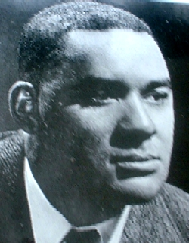  Richard Wright | 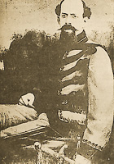  Vicente Riva Palacio | 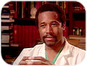  Ben Carson |   Carl Sagan

Review and preview.
Unfinished business from Weeks 1-2.
Preview of next week’s Midterm:
A comparison of Wright's, Riva Palacio's, and Sagan’s views of education. These 3 writers lived in different times and places. Are their views of education radically different? What would each author say about the education you received as a child? As an adult? The education you are presumably receiving right now?
Old Main (one of Wayne State’s most beautiful buildings)

Interacting with Comics
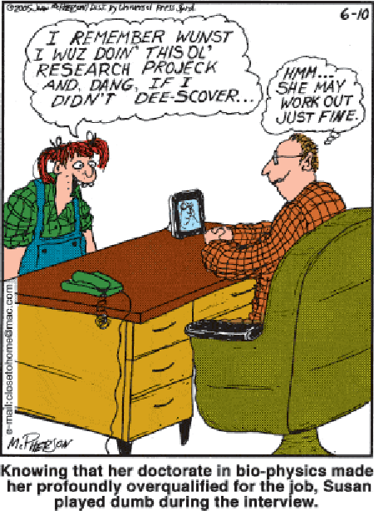
I. The Dumb Biophysicist
II. Latinos in the USA
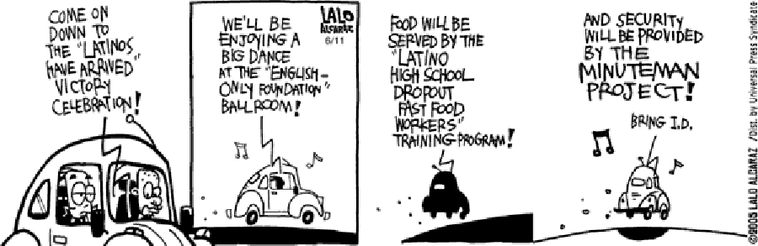

→Reminder: Next week, class is 10-6, Lab A, Undergraduate Library

Week 4: 2/2/08 (10-6, Lab A, UG Library)
10:00: Preview of Midterm I
10:30: Midterm I
- All questions for this midterm will be taken from among the following:
  - Retell: “The Library Card” (Wright, 19-26), “In Praise of Literacy” (Sagan, 31-32),
  - Retell and interpret: 1. “Falling Asleep in Class” (p. 4), “Caught in a Lie” (p. ix), “If Not Higher” (pp. 12-14), “King David's Crime” (pp. 14-15), “The Zax” (http://youtube.com/watch?v=spOIbEJmH4Y), “The Good Example” (Riva Palacio, 26-27), “The Dumb Biophysicist” (above), “Latinos in the USA” (above)
- Grammar: Mastery of apostrophe; Editing sentences similar to “Thirteen Lousy Sentences” (pp. 10-11)
- “Your Flag Decal” (John Prine; pp. 17-18), answer questions a-j.
- Solve and Explain: Creative Thinking in Action (p. xi)

11:30-2:30: Computer Workshop I: Please consult and submit the Computer Lab Exercise file as an attachment (file is available at: http://www.is.wayne.edu/mnissani/20302005/Wk3.htm). For a hard copy of that file, see pp. 41-43 of your coursepack).
3-4: Second apostrophe competition
4-6: Essay Writing Workshop
In this workshop, we shall write together a Learning Essay. The Assignment is this: Compare and contrast your educational experiences and dreams to the educational experiences and dreams depicted in Richard Wright's "The Library Card."
Note: By dreams we mean the types of educational realities that they would like to see, both for their own personal education and for society as a whole (length: 500<n<1300 words).

Required Essay Outline:
- Title of Essay
- Introduction
- Describe one relevant (similar to Wright’s, different from Wright’s, reminiscent of Wright’s) educational experience—a specific episode—from your own life. (e.g., by specific episode we mean something that happened to you while you were in 2nd grade, just before Christmas; OR: something that happened to you in your first year in college, in Prof. Washington’s class)
- The educational experiences of "The Library Card." Note: don’t retell the story; focus instead on the learning aspects of Wright’s account.
- Compare and contrast your episode to a comparable episode in Wright’s narrative.

Week 5: 2/9/08

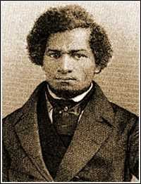  Frederick Douglass | 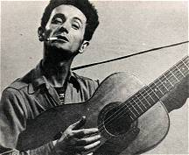  Woody Guthrie

Questioning our Answers: This Land is your Land
Perhaps the greatest block to intellectual, moral, and spiritual progress is our inability to question our beliefs. Deep down we say to ourselves: Other people, sure, we can see that they could be wrong. But me wrong? Me brainwashed? With training, most people can partially overcome this universal human failing. Remember: The crow’s nest is a frightening place to climb up to or perch in—but the view is fantastic.

- Listen to the first stanza of this song, music and words.
- Now kindly hand your instructor a written answer: What’s this familiar song about? What does it celebrate?
- A review of written answers
- Listen to / read (class handout) the entire song.
- What is this song really about?
- Prepare a class presentation, focusing on these questions:
  - Was my written answer wrong?
  - Why didn’t I know what this popular song is REALLY all about?
- Class discussion: Lessons from this exercise

Optional Topic/Handout

Read by next week: The Stub Book (57-59)

Week 6: 2/16/08

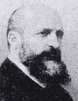  Pedro Alarcón | 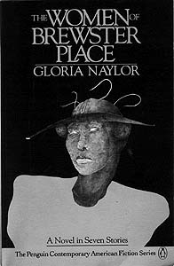 | 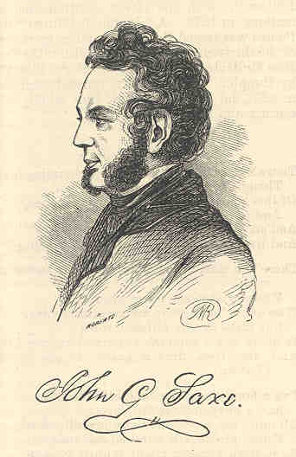  John Godfrey Saxe

Review and Preview.

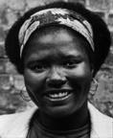  Gloria Naylor | Wonders of Books on Tape (note: We’re deliberately using books on tape for this class activity, not a movie—why?): Kiswana Browne (see also pp. 91-98)  Discussion topics:  - Who is right about the name change, Kiswana or her mother? Explain.  - Who is right about fighting for one’s people, Kiswana or mama? Explain.  - What does it mean, fighting for one’s people—aren’t we all brothers and sisters?  - Does this story bring to mind a personal experience with a parent or child?  - In the story, Kiswana understands, perhaps for the first time, that her mother is a fellow human being. Which trivial episode helps her see their common humanity?

Item in the News

Read by next Week: “The Founding Sachems” (pp. 141-143).

Week 7: 2/23/07

 | There is no frigate like a book  To take us Lands Away--  Emily Dickinson | 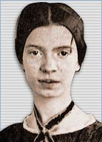

Review of previous week and a preview of this workshop.

Critical Thinking in Action II. We still pride ourselves on being a free country, and we trace our freedom to certain historical events. This workshop will explore these beliefs, and attempt to trace our love of freedom to its true historical origins.
- What do we mean by freedom?
- A taste for freedom must be acquired, or re-acquired. Where did we, Americans, acquire this taste? Which men and women contributed most to this concept?
- Now let’s read aloud, together, a recent article (pp. 141-143). What is the author’s viewpoint on the origins of our freedom? Does his viewpoint make sense? If so, how come no one told it to us before, in our schools, media, government publications?

Geography Fun Competition (pp. 144-145)

Analysis of contemporary media text

Read by Next Week: Coursepack, pp. 68-76.

Study for Midterm II.
→Reminder: Next week, class is 10-6, Lab A, Undergraduate Library

Week 8: 3/1/08 (Lab A, UG Library)

  Christopher Columbus |   President Hugo Chavez |   Leonard Pitts, Jr.

10:00: Preview of Midterm II
10:30: Midterm II.
Computer Workshop (cont.)

In-class revision of Midterm I for a higher grade (final grade for this will be the average of the first and second grades)

Writing Workshop: Should I celebrate Columbus Day?
- Background material: pp. 68-76.
- We shall write this essay together, following instructions on p. 68 (or at: http://www.is.wayne.edu/mnissani/20302005/Columbus.doc).

Class Discussion: Offer a summary of, critical evaluation of, and a personal response to, Pitts’ views on African-Americans and gays (pp. 76-77).

Read by Next Session: "Marriage is a Private Affair" (pp. 78-81) and "Contents of the Dead Man's Pockets" (81-90).

Week 9: 3/8/08

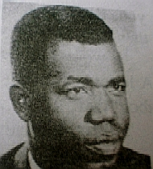  Chinua Achebe | 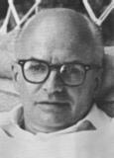  Jack Finney  (1911-1995)

Review and preview.

Topic: TBD

Analysis of Contents of the Dead Man's Pockets (p. 81-90):
    - Five levels
    - Artistic features
    - Interdisciplinary features

Read by 3/22/08: Icecaps and hurricanes: the proof of climate change (pp. 110-112; also available at: http://www.is.wayne.edu/mnissani/20302005/icecaps.htm)

→Note: There is no class next week!

Week X: 3/15/08: NO CLASS

Week 10: 3/22/08

  An Iceberg, Newfoundland, Canada |   Michael Moore

Viewing and Analysis of Michael Moore’s Congressional Pimp (I. http://youtube.com/watch?v=ZGN7b37dn4c; II. http://youtube.com/watch?v=suK2M3Y2pfU)

Science in the News: Icecaps and hurricanes: the proof of climate change (pp. 110-112; also available at: http://www.is.wayne.edu/mnissani/20302005/icecaps.htm) OR: A more recent article distributed in class

Discussion questions:
- The author documents climate change through several examples. Describe and explain each example.
- Can you come up with additional examples showing that climate change has arrived?
- Do you agree with the author that climate change is real? Why?
- What are your personal strategies for dealing with climate change?
- Can we, or should we do anything about climate change?

Week 11: 3/29/08

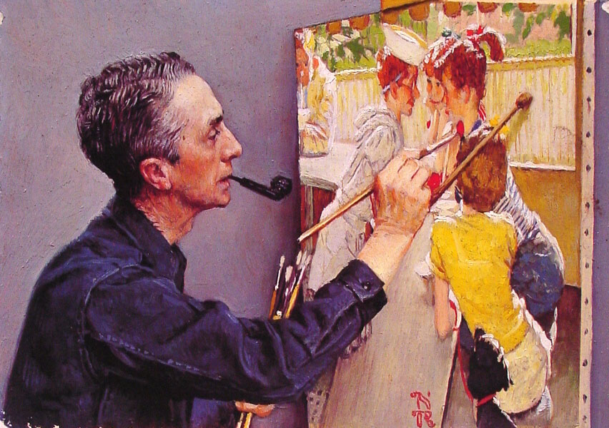  Norman Rockwell: Self-Portrait (of himself painting a picture) |   Julia Sweeney | 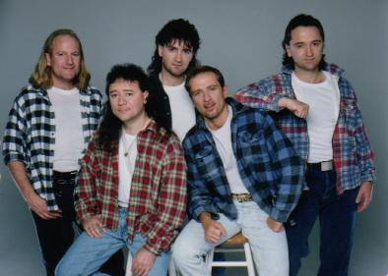  The Eagles

Review and Preview.

The A, B, C of Text Interpretation
    - What’s the moral of Norman Rockwell’s painting, “The Gossips?”(p. 56)
    - Hotel California (p. 112). Sometimes, though, interpretation is difficult. In such cases, we may consult the author, someone else—or let our imagination soar! Let’s listen to this great song, and then try to figure out: What are they talking about?

Summarizing, Critically Evaluating, and Assimilating Julia Sweeney’s “Letting Go of God.”
According to program notes, Julia Sweeney, an ex-Catholic, tells (in 30 minutes) how her faith began to crack after reading a most alarming book—the Bible. Please take notes while listening to Julia’s account. You may then be asked to contribute to a distillation of Sweeney’s detailed argument. We’ll start by retelling in our own words her argument as vividly and convincingly as we can. Once we’re clear about her reasons for letting go of God, we’ll try to find the strengths and flaws of her position (e.g., Is her argument a good one? Why? Is it a bad one? Why? Is it a touching essay? Is she sincere? Does she do a good job, or is she a bad reader/thinker? Any other good points? Bad points?). Our next topic will be personal: The meaning of Julia Sweeney’s personal search to each one of us.

Analysis of a Recent (TBD) Brief Internet Film

Read by Next Session: "A Painful Case" (pp. 118-122)

Week 12: 4/5/08


Al Gore

Synopsis of Al Gore's “An Inconvenient Truth”

While viewing the film, we’ll focus on these questions: 1. Describe and explain 3 distinct present impacts of climate change. 2. What are, according to Gore, the 3 causes of humanity’s collision with Earth. Describe and explain. 3. What are 3 misconceptions about climate change? Describe and explain.

Week 13: 4/5/08

Chinua Achebe | Jack Finney  (1911-1995) | 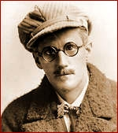  James Joyce

Oral Communication Workshop: With the help of class instructor and fellow students, write a brief outline for one of the three topics below, practice your presentation, and, based on this outline, give a 2-6 minute talk to the class:

Tradition or Common Humanity: Was Okeke (Nnaemeka's father in "Marriage is a Private Affair") right or wrong in disowning his son?
OR
Leisure or Pleasure: Should you seek advancement on your job, or spend some quality time with loved ones?
OR
Should I celebrate Columbus Day?
.
Rules:
- Your presentation must be spoken, not read
- Develop an outline of your presentation in class
- If you are too anxious about speaking in public, you might want to give it a try anyway. But you don’t have to. If you submit an outline, you’ll get full credit for this formal class assignment.

Week 14: 4/19/08

Unfinished business.
A preview of ISP courses.
Looking back on ISP 2030: What have we learned this past semester?
Student Evaluations of Teaching.
Preview of Midterm III
Optional reviews for Make-Up Midterm II
“Happy Christmas” (John Lennon): Lyrics Video: How is the song different from Wal-Mart’s Christmas songs?

Week 15: 4/26/08

10:00: Preview of Midterm III
10:30: Midterm III
Optional Make-up: Midterm II
Farewells

