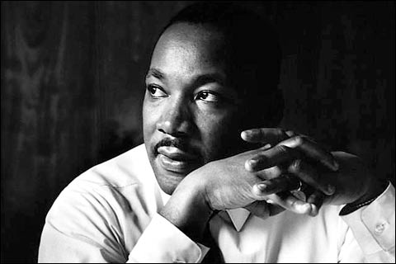
Internet Material for the Martin Luther King Workshop

Memphis Sanitation Strike:
"During a heavy rainstorm in Memphis on February 1, 1968, two black sanitation workers had been crushed to death when the compactor mechanism of the trash truck was accidentally triggered. On the same day in a separate incident also related to the inclement weather, 22 black sewer workers had been sent home without pay while their white supervisors were retained for the day with pay. About two weeks later, on February 12, more than 1,100 of a possible 1,300 black sanitation workers began a strike for job safety, better wages and benefits, and union recognition."

Dr. King announced a Poor People’s Campaign that would culminate in Poor People’s March on Washington with demands for an Economic Bill of Rights guaranteeing employment and a living wage, national economic support for those unable to work and decent housing for all.
He was assassinated on April 4, 1968 as he prepared a march in support of sanitation and other municipal employees.
The Mission Statement of the 2004 Million Worker March declares:
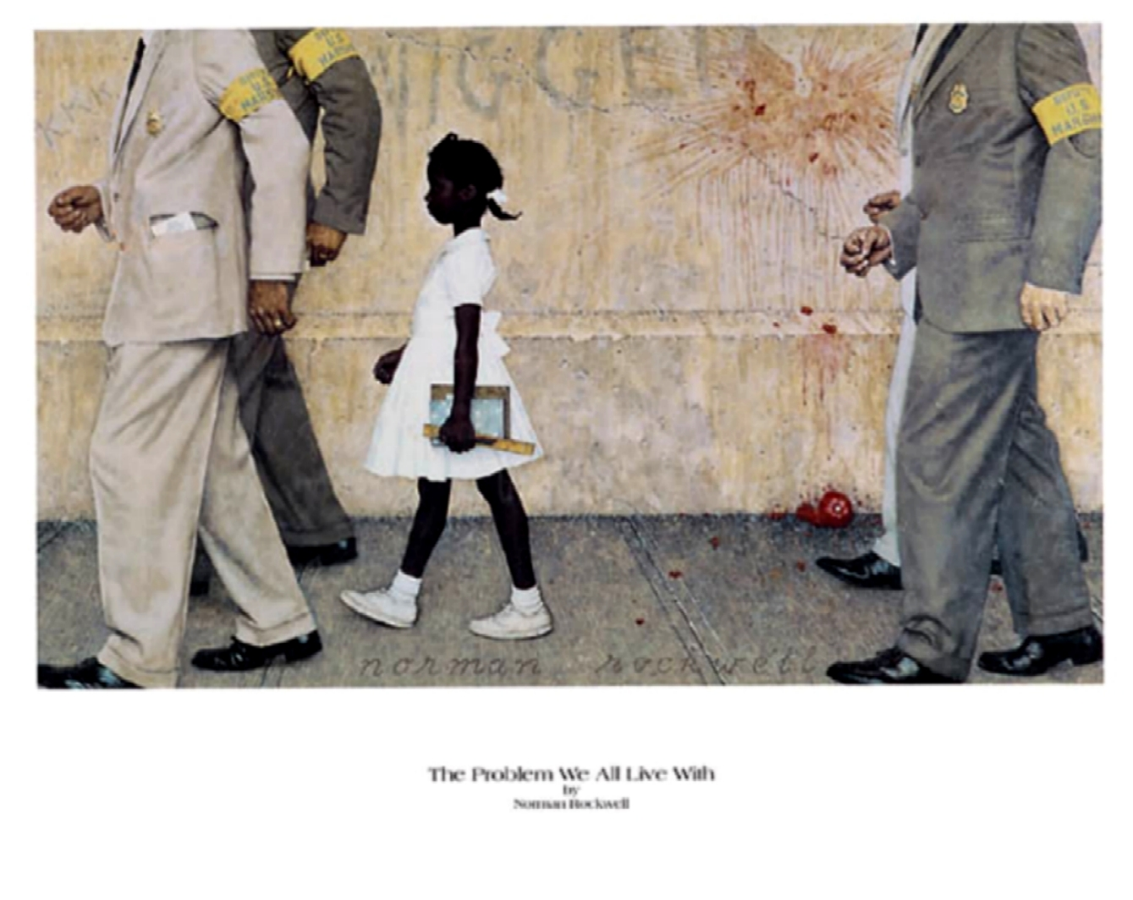
“Thirty-six years ago, Dr. Martin Luther King, Jr. summoned working people across America to a Poor People’s March on Washington to inaugurate “‘a war on poverty at home.’ ‘The United States government,’ he proclaimed, ‘is one of the greatest purveyors of violence in the world. America is at a crossroads in history and it is critically important for us as a nation and society to choose a new path and to move on it with resolution and courage.’
“Working people are under siege while new wars of devastation are launched at the expense of the poor everywhere.
“The Million Worker March will revive and expand a great struggle for fundamental change, as we forge together a social, economic and political movement that will transform America.”
____________________________________
Note: In April 1967 King already had a premonition that the media will try to pigeon-hole him, not as a humanitarian, not as Christian, but as a civil rights activist. Here is his reply:
For those who ask the question, "Aren't you a civil rights leader?" and thereby mean to exclude me from the movement for peace, I have this further answer. In 1957, when a group of us formed the Southern Christian Leadership Conference, we chose as our motto: "To save the soul of America." We were convinced that we could not limit our vision to certain rights for black people, but instead affirmed the conviction that America would never be free or saved from itself until the descendants of its slaves were loosed completely from the shackles they still wear. In a way we were agreeing with Langston Hughes, that black bard of Harlem, who had written earlier:
O, yes, I say it plain,
America never was America to me,
And yet I swear this oath-
America will be!
Now it should be incandescently clear that no one who has any concern for the integrity and life of America today can ignore the present war. If America's soul becomes totally poisoned, part of the autopsy must read "Vietnam." It can never be saved so long as it destroys the deepest hopes of men the world over. So it is that those of us who are yet determined that "America will be" are led down the path of protest and dissent, working for the health of our land.
Click here to listen to the mountaintop speech
____________________________________
The Martin Luther King You Don't See On TV
Media Beat (1/4/95)
By Norman Solomon
It's become a TV ritual: Every year in mid-January, around the time of Martin Luther King's birthday, we get perfunctory network news reports about "the slain civil rights leader."
The remarkable thing about this annual review of King's life is that several years — his last years — are totally missing, as if flushed down a memory hole.
What TV viewers see is a closed loop of familiar file footage: King battling desegregation in Birmingham (1963); reciting his dream of racial harmony at the rally in Washington (1963); marching for voting rights in Selma, Alabama (1965); and finally, lying dead on the motel balcony in Memphis (1968).
An alert viewer might notice that the chronology jumps from 1965 to 1968. Yet King didn't take a sabbatical near the end of his life. In fact, he was speaking and organizing as diligently as ever.
Almost all of those speeches were filmed or taped. But they're not shown today on TV.
Why?
It's because national news media have never come to terms with what Martin Luther King Jr. stood for during his final years.
In the early 1960s, when King focused his challenge on legalized racial discrimination in the South, most major media were his allies. Network TV and national publications graphically showed the police dogs and bullwhips and cattle prods used against Southern blacks who sought the right to vote or to eat at a public lunch counter.
But after passage of civil rights acts in 1964 and 1965, King began challenging the nation's fundamental priorities. He maintained that civil rights laws were empty without "human rights" — including economic rights. For people too poor to eat at a restaurant or afford a decent home, King said, anti-discrimination laws were hollow.
Noting that a majority of Americans below the poverty line were white, King developed a class perspective. He decried the huge income gaps between rich and poor, and called for "radical changes in the structure of our society" to redistribute wealth and power.
"True compassion," King declared, "is more than flinging a coin to a beggar; it comes to see that an edifice which produces beggars needs restructuring."
By 1967, King had also become the country's most prominent opponent of the Vietnam War, and a staunch critic of overall U.S. foreign policy, which he deemed militaristic. In his "Beyond Vietnam" speech delivered at New York's Riverside Church on April 4, 1967 — a year to the day before he was murdered —King called the United States "the greatest purveyor of violence in the world today."
From Vietnam to South Africa to Latin America, King said, the U.S. was "on the wrong side of a world revolution." King questioned "our alliance with the landed gentry of Latin America," and asked why the U.S. was suppressing revolutions "of the shirtless and barefoot people" in the Third World, instead of supporting them.
In foreign policy, King also offered an economic critique, complaining about "capitalists of the West investing huge sums of money in Asia, Africa and South America, only to take the profits out with no concern for the social betterment of the countries."
You haven't heard the "Beyond Vietnam" speech on network news retrospectives, but national media heard it loud and clear back in 1967 — and loudly denounced it. Time magazine called it "demagogic slander that sounded like a script for Radio Hanoi." The Washington Post patronized that "King has diminished his usefulness to his cause, his country, his people."
In his last months, King was organizing the most militant project of his life: the Poor People's Campaign. He crisscrossed the country to assemble "a multiracial army of the poor" that would descend on Washington — engaging in nonviolent civil disobedience at the Capitol, if need be — until Congress enacted a poor people's bill of rights. Reader's Digest warned of an "insurrection."
King's economic bill of rights called for massive government jobs programs to rebuild America's cities. He saw a crying need to confront a Congress that had demonstrated its "hostility to the poor" — appropriating "military funds with alacrity and generosity," but providing "poverty funds with miserliness."
How familiar that sounds today, more than a quarter-century after King's efforts on behalf of the poor people's mobilization were cut short by an assassin's bullet.
As 1995 gets underway, in this nation of immense wealth, the White House and Congress continue to accept the perpetuation of poverty. And so do most mass media. Perhaps it's no surprise that they tell us little about the last years of Martin Luther King's life.
--------------------------------------------------------------------------------
Jeff Cohen and Norman Solomon are syndicated columnists and authors of Adventures in Medialand: Behind the News, Beyond the Pundits (Common Courage Press).
____________________________________

Class Gateway | Moti Nissani's Homepage | Dept. of Interdisciplinary Studies

